1. Soil C pool data was calculated from C% and bulk density (Table 1, page 1789)

Soil C pool (OCg_cc) = OC * Db (bulk density)

The paper does not report carbon density directly. We calculated carbon density from Table 1, which reported percent organic carbon and bulk density, but not carbon pool.

The mean soil C data from different depths for each site was calculated by SAS.

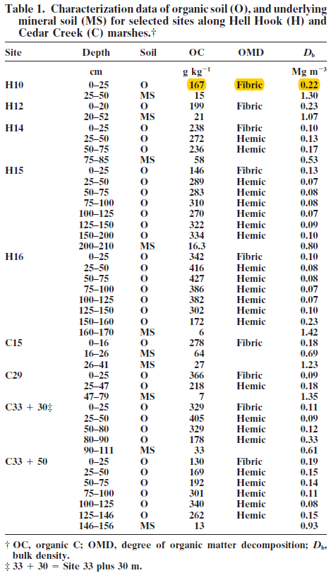

2. Soil C rate data may come from the text on page 1794.

Meng was not able to find the soil C rate data. (‘salt marsh rate’ tab, row 82, 83)

***[Response from Blanca]*** *see abstract:*

*During the last 150 yr, the rate of C sequestration averaged 83.5 +- 23 g m2 yr1.*

*During the next century, future C sequestration in the newly formed coastal marsh soils averaged 400 +- 162 gm2 yr1*

